Exercise 1: Simple demand-supply model

Task: In the first exercise you will learn the basic syntax and structure of GAMS. The code specifying a simple demand-supply model is provided and we will work through it together. The model includes two commodities (agriculture, industry).

Demand curve 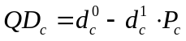
Supply curve 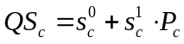
Equilibrium 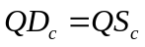

Variables 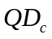 quantity demanded
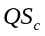 quantity supplied
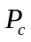 market price

Parameters 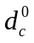 demand curve intercept
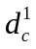 price elasticity of demand (really the slope)
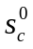 supply curve intercept
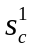 price elasticity of supply (really the slope)

Hints and tips: We’ll go through the code together and discuss how each of the components are specified - so there are no hints and tips at this stage.

Simulation:
Simulate a 20% decrease in the agricultural supply curve intercept term. To do this you first solve the model using initial values (i.e., create a base solution). Then change one of the exogenous parameters in the model and resolve. You can compare the initial and final values of the variables in order to estimate the impact of the exogenous shock.

You will need to add the following two new lines of code just before the ‘display’ command at the end of the program:
s0(‘agr’) = s0(‘agr’) * 0.8;
solve mmmod using mcp;

Questions and exercises:
- How do the following variables change after simulating the supply shock for agriculture? Quantity demanded (QD); Quantity supplied (QS); Prices (P)
- What is the impact of the agricultural shock on industrial production and prices? Explain why this is the case?

